**United States Department of Agriculture**

Food and Nutrition Service

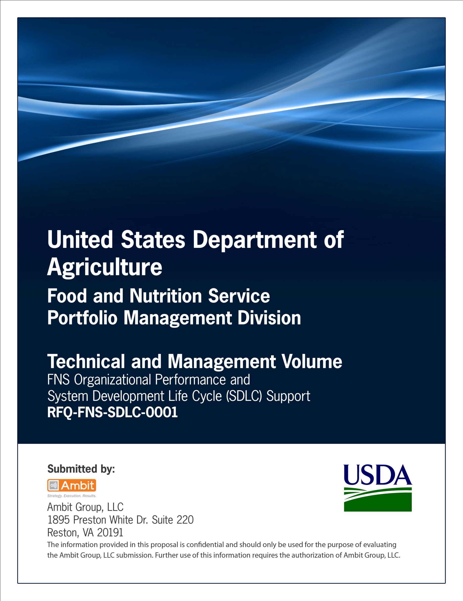

**FNS Office of Information Technology**

**Portfolio Management Division (PMD)**

**FNS Project Management Plan**

**for**

**[Project or System Name]**

**Version 1.1**

September 09, 2013

**Revision History**

|  |  |  |  |
| --- | --- | --- | --- |
| **Version** | **Date** | **Author** | **Change Description** |
| 1.0 | 03-12-2013 | IT Governance Branch (ITGB) | Created the document. |
| 1.1 | 09-09-2013 | IT Governance Branch (ITGB) | Re-formatted the document. |
| 1.2 |  |  |  |
| 1.3 |  |  |  |

**Contact Information**

|  |  |
| --- | --- |
| **Area of Concern** | **Contact Person** |
| IT Governance Lead | Kevin Russ |
| SDLC Coordinator | Syed Jaffery |
| ITIRB Coordinator | Sunny Dilawari |
| Portfolio Management Division Director, Chief Portfolio Officer | Jacqueline Butler |
| Program Management Branch Chief | Allison Willcox |

Contents

Glossary 4

1. General Information 5

1.1. Purpose, Scope, and Objectives 5

1.2. System Overview 6

1.3. RACI Chart 7

1.4. Points of Contact 8

1.5. Project Deliverables 9

1.6. Assumptions, Dependencies, and Constraints 9

2. Managerial Process Plans 10

2.1. Start-up Plans 11

2.2. Control Plan 11

2.3. Risk Management Plan 13

Appendix A: Staffing Management Plan 14

Appendix B: Scope Management Plan 16

Appendix C: Requirements Control Plan 17

Appendix D: Schedule Management Plan 18

Appendix E: Cost Management Plan 20

Appendix F: Procurement Management Plan 22

Appendix G: Project Communication Plan 25

Appendix H: Risk Management Plan 27

Appendix I: References 31

Approvals/Signatures 32

# Glossary

| **Acronym** | **Description** |
| --- | --- |
|  |  |
|  |  |
|  |  |
|  |  |
|  |  |
|  |  |
|  |  |
|  |  |

# General Information

## Purpose, Scope, and Objectives

**Purpose of the System**

Describe the purpose of the system.

**Scope**

Provide a description of the intended scope of the system, how it will accomplish its purpose.

**Objectives**

List the functional Capabilities that will be provided in a solution. Describe in terms of problems that will be solved, issues to be addressed or functions to be performed.

1. Capability Shortfall, Problem or Issues to be addressed
   * 1. Improvement#1
     2. Improvement #2
     3. Improvement #3

For example:

* Provide optimal reach to audiences
* Better serve specific audiences
* Broaden user base

1. Functions

List functions to be performed.

* + 1. Function #1
    2. Function #2
    3. Function#3

For example:

* Provide updated and expanded data
* Enhance functionalities and capabilities
* Employ up-to-date technology

**Business Needs**

Specify business needs to be satisfied.

**Start and End Dates of the Project**

MM/DD/YYYY to MM/DD/YYYY.

**Exclusions**

Specify any scope or objectives to be excluded.

## System Overview

Provide a brief system overview description as a point of reference for the remainder of the document.

**System Description**

Describe the system in narrative form using non-technical terms.

**Name of System**

Identify the system by its official Title. Also indicate acronym or short name if applicable.

**Sponsor Organization**

Enter the name of the organization that initiated and is champion of this effort.

**System Category**

Select from following categories:

1. Small Project
   * + 1. Expected cost is less than $25,000
       2. Risk and complexity are low
       3. An individual unit is involved
       4. Expected duration is less than 4 months
2. Medium Project
   * + 1. Expected cost is $25,000 to $500,000
       2. Complexity is medium to high
       3. Multiple people/departments are involved
       4. Expected duration is less than a year
3. Large Project
   * + 1. Expected cost is greater than $500,000
       2. Full Project Management methodology is required
       3. Expense, risk, or complexity are high
       4. Large number of people/departments are involved
       5. Anticipated lifecycle is long

## RACI Chart

This section displays an example RACI Chart for the project – update accordingly.

| **Phases** | **Templates** | **Roles** | | | | | | | | |
| --- | --- | --- | --- | --- | --- | --- | --- | --- | --- | --- |
|  | R-Responsible  A-Accountable  C-Consult  I-Informed | **Project Sponsors** | **SME’s** | **OIT PM** | **Business Analyst** | **IT Architect** | **Network Managers** | **Developers** | **Testers** | **End Users** |
| Initiation | **Business Case** | R | CI | A | I | I | I | I | I | I |
| **Project Plan** | A | C | R | I | I | I | I | I | I |
| Requirements Gathering & Analysis | **PTA, PIA, SORN, Electronic Information System Questionnaire for Records Management Scheduling** | C | C | R/A | I | I | I | I | I | I |
| **System Requirements Specification** | C | C | A | R | I | I | I | I | I |
| Design | **Procurement Documents** | A | C | R | I | I | I | I | I | I |
| **System Design Document** | I | I | A | C | R | C | C | I | C |
| Development | **Test Plan** | I | I | A | C | C | I | I | R | I |
| Integration | **Transition Plan** | I | I | A | C | R | I | C | I | I |
| Testing | **Test Results** | I | I | A | C | C | I | C | R | I |
| Implementation | **Installation Document** | I | I | A | C | R | C | R | I | I |
| **Application Guide** | R | R | A | R | C | C | C | I | I |
| Operations/  Maintenance | **Standard Operating Procedures** | I | I | A | I | I | R | R | R | I |
| Disposition | **System Disposition Plan** | R | I | R/A | I | I | I | I | I | C |
| **Post Termination Review Report** | C | I | R/A | I | I | I | I | I | C |

## Points of Contact

List the names, titles, and contact information of the major participants in the project.

| **Name** | **Title** | **Contact Phone Number** | **Contact Email** |
| --- | --- | --- | --- |
|  | Project Sponsor |  |  |
|  | OIT Project Manager |  |  |
|  | SME |  |  |
|  | Business Analyst |  |  |
|  | Architect |  |  |
|  | Developer |  |  |
|  | Tester |  |  |
|  | End User |  |  |

## Project Deliverables

List the major items to be delivered to the customers, subcontractors, integrators, or other parties. As appropriate, list the deliverables, their recipients, interim and final delivery dates, and delivery method.

|  |  |  |  |  |
| --- | --- | --- | --- | --- |
| **Deliverable** | **Recipients** | **Delivery Date** | **Delivery Method** | **Comments** |
| Enter the name of the deliverable. | Enter names of the people whom the deliverables will be sent. | Enter delivery date. | Email  Mail  Physical Folder. | Enter comments (if any). |
| For example: |  |  |  |  |
| Software Requirements Specification | Project Sponsor  SME  OIT PM | 09/31/2011 | Email | None |

## Assumptions, Dependencies, and Constraints

List any user assumptions, dependencies and constraints that will affect development and operation of the system.

**Assumptions**

State the assumptions associated with development of the system, where assumptions are defined as future situations, beyond the control of the project, whose outcomes influence the success of a project.

The following are examples of assumptions:

1. Availability of a hardware/software platform
2. Pending legislation
3. Court decisions that have not been rendered
4. Future trends in immigration and naturalization
5. Developments in technology

**Dependencies**

Describe any external events or externally-supplied items upon which the project depends.

1. Dependency #1
2. Dependency #2
3. Dependency #3

For example: Data needs to be migrated into the system from external source.

**Constraints**

State the constraints associated with the development of the system, where constraints are defined as conditions outside the control of the project that limit the design alternatives.

The following are examples of constraints:

1. Government regulations
2. Technical standards imposed on the solution

For example, the use of a specific Database Management System.

1. Strategic decisions
2. Constraints exist because of real business conditions

For example, a delivery date is a constraint only if there are real business consequences that will happen as a result of not meeting the date. If failing to have the subject application operational by the specified date places the FNS in legal default, the date is a constraint.

**Interfaces**

Describe whether this system relates to or depends on any existing system.

|  |  |
| --- | --- |
| System Name | Relationship |
| For example |  |
| System XYZ | Web service provider |

# Managerial Process Plans

Depending on the size of the project, you may need to prepare some or all of the plans. Please refer to the table below.

(Note: This table serves as a guideline. Project Manager, Branch Chief and SDLC Governance Lead will decide the plans to prepare for the project depending on the scope and size of the project. )

|  |  |  |  |
| --- | --- | --- | --- |
|  | **Small** | **Medium** | **Large** |
| **Start-up Plans** |  |  |  |
| Staffing Management Plan |  |  | ✓ |
| Scope Management Plan | ✓ | ✓ | ✓ |
| **Control Plan** |  |  |  |
| Requirements Control Plan | ✓ | ✓ | ✓ |
| Schedule Management Plan | ✓ | ✓ | ✓ |
| Cost Management Plan |  | ✓ | ✓ |
| Procurement Management Plan |  | ✓ | ✓ |
| Project Communication Plan | ✓ | ✓ | ✓ |
| AAR |  | ✓ | ✓ |
| **Risk Management Plan** | ✓ | ✓ | ✓ |

## Start-up Plans

**Staffing Management Plan**

The Staffing Management Plan defines the project organization, resource planning (people) and process for managing project staffing. It describes when and how human resources will be brought onto and taken off of the project. The Staffing Management Plan provides for orderly and efficient management of human resources within the context of the overall Project Management Plan.

Refer to Appendix A for detailed template.

Specify whether this plan is used or not.

**Scope Management Plan**

The Scope Management Plan discusses the development, baseline and control of the Work Breakdown Structure (WBS), the primary scope management tool. The Scope Management Plan also describes how scope changes will be managed and integrated into other project areas, such as cost and schedule.

Refer to Appendix B for detailed template.

Specify whether this plan is used or not.

## Control Plan

Control plan describes how the project will control and report on the project status and activities. It specifies the frequency at which the various project status indicators are to be monitored and specific events that could trigger a status evaluation.

**Requirements Control Plan**

Requirements control plan specifies the steps to be followed if there are any changes in the requirements.

Refer to Appendix C for detailed template.

Specify whether this plan is used or not.

**Schedule Management Plan**

The Schedule Management Plan describes who owns and manages the project schedule, processes that control schedule change, reporting, updating and analysis and the process for establishing a baseline schedule.

Refer to Appendix D for detailed template.

Specify whether this plan is used or not.

**Cost Management Plan**

The Cost Management Plan describes the process for implementing change control over cost estimates and the project time-phased cost baseline. This covers budget preparation and maintenance. It details the process for authorizing and expending project funds. The plan includes the steps taken when the performance measurement system identifies major or minor cost vs. budget variances. The plan also covers the timing and distribution of cost and performance reports.

The objective of the cost management plan is to make certain that project costs are monitored and controlled and that the project is delivered within budget.

Refer to Appendix E for detailed template.

Specify whether this plan is used or not.

**Procurement Management Plan**

The Procurement Management Plan discusses the scope of procurements that will exist for the project, which include consultants, additional software and licenses, and employee training. It describes the types of contracts appropriate for the procurement, the solicitation and evaluation processes, and team/stakeholder responsibilities relative to the development of procurement documents.

Refer to Appendix F for detailed template.

Specify whether this plan is used or not.

**Project Communication Plan**

The Project Communication Plan describes how project information is distributed, reviewed, updated and filed. The plan describes the information product, how it is produced, who produces it, when it is produced and to whom it is distributed.

Refer to Appendix G for detailed template.

Specify whether this plan is used or not.

## Risk Management Plan

The Risk Management Plan describes how risks are identified, tracked, assessed and responded to. The plan identifies the tools used to capture identified risks, risk categories, assigned owners, calculated probabilities, identified thresholds or triggers for instigating mitigating action and contingency plans.

Refer to Appendix H for detailed template.

Specify whether this plan is used or not.

# Appendix A: Staffing Management Plan

**Staffing Management Plan Purpose**

Describe the purpose of the Staffing Management Plan.

**RACI**

Please refer to RACI chart in Section 1.3.

**Project Organization**

Specify organization, roles, responsibilities and budget in the following table:

|  |  |  |  |
| --- | --- | --- | --- |
| Organization | Role | Responsibility | Budget Allocation |
| Specify the sources of the staff:  Internal from your department  Internal from another department within your organization  Hiring of a new employee Hiring of contractors | Enter Role details. | List responsibilities. | Specify Budget details. |
| For example: |  |  |  |
| Contractor | Java Developer | Java Development | $60,000 |

**Resource Staffing Plan**

Describe what resources are required and when they are required.

|  |  |
| --- | --- |
| Resource Required | Phase |
| Enter name of the role. | Enter the phase in which the resource is required. |
| For example: |  |
| Developer | Phase I |

**Resource Constraints**

Document any known constraints regarding resources. Constraints may be project based, defining specific requirements and limitations within the project objectives, or organizationally based, defining limitations or requirements of the organization to adequately staff the project and meet project requirements and needs.

1. Constraint #1
2. Constraint #2
3. Constraint #3

**Staffing Contingency Plans**

Describe the process for developing contingency plans, providing alternatives should critical resources not be available when required.

Contingencies should answer questions such as: What happens if the Project Manager leaves? What if budgets are curtailed?

**Training Requirements**

Specialized training may be identified and required for project team members or staffing. Specify any training that will be needed to ensure the necessary skill levels needed for the project.

|  |  |  |
| --- | --- | --- |
| **Type of Training** | **Personnel to be Trained** | **Training Methods** |
| Provide the type of training required by the staff. | Specify the roles of staff to be trained. | Specify training methods. |
| For example:   * Automation Testing training | For example:   * Software Tester | For example:   * Lectures * Consultations * Mentoring * Computer-assisted training |

# Appendix B: Scope Management Plan

The Scope Management Plan discusses the development, baseline and control of the Work Breakdown Structure (WBS), the primary scope management tool. The Scope Management Plan also describes how scope changes will be managed and integrated into other project areas, such as cost and schedule.

**Purpose of Scope Management Plan**

Describe the purpose of the Scope Management Plan.

**Scope Baselining**

Describe the process for establishing the scope baseline.

**Scope Change Management Process**

Describe the scope (WBS) change control process as it pertains to project integrated change control.

**Work Breakdown Structure**

The plan should discuss the process the project will follow to develop the WBS (an outline or graphical depiction of the project scope). For example:

# Appendix C: Requirements Control Plan

**Purpose of Requirements Control Plan**

Describe the purpose of Requirements Control Plan.

**Reporting Requirement Changes**

Specify the mechanisms used for reporting the changes to the project requirements.

For example: Change control Form

**Accessing the Impact of Requirement Change**

Describe how to assess the impact of requirement changes on product scope and quality, and on project schedule, budget, resources, and risk factors.

**Requirement Control Steps**

Incorporate the tasks and effort to perform the requirements control steps into the project’s work breakdown structure and schedule.

1. Step #1
2. Step #2
3. Step #3

For example:

1. When changes are to be made in the requirements after the SRS has been released, the changes shall be brought to the attention of the committee and discussed.
2. Any changes that are to be made will be with the prior approval of the committee and only if feasible and permissible within the constraints of the project mentioned, and resources in terms of knowledge and skill of the developer required.
3. Once the changes have been made to the SRS document, an updated version of the SRS shall be released and circulated to the committee.

# Appendix D: Schedule Management Plan

**Schedule Management Plan Purpose**

Describe the purpose of Schedule Management Plan.

**Control Mechanisms**

Specify the control mechanisms used to measure the progress of the work completed at milestones.

**Methods Used**

Specify the methods and tools used to compare actual schedule performance to planned performance and to implement corrective action when actual performance deviates from planned or required performance.

For example: PERT Chart, Gantt chart

**Gantt Chart/PERT Chart**

A project schedule in the form of a Gantt chart or PERT Chart should be created, preferably in a project tracking tool.

For example: (Gantt Chart)

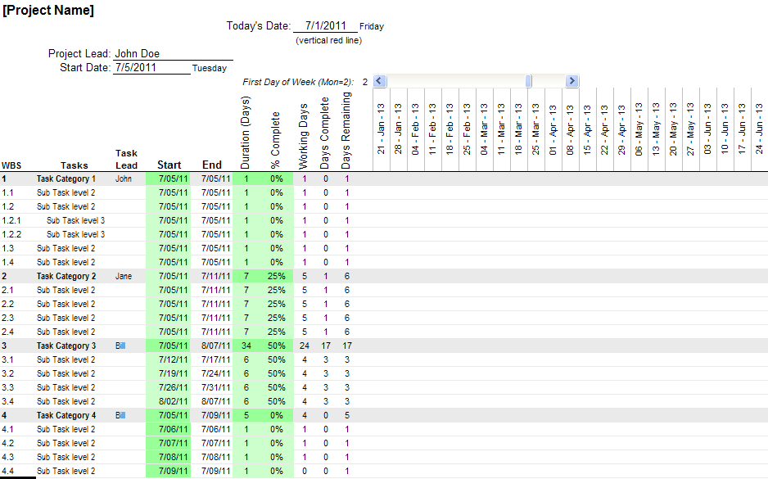

**Contingency Procedures**

Describe how contingency buffers will be tapped and revised when actual performance falls behind estimates.

**Schedule Change Procedures**

Describe how and when schedules will be modified and how agreement and commitment to the revised schedules will be achieved.

# 

# Appendix E: Cost Management Plan

**Purpose of Cost Management Plan**

Describe the purpose for preparing cost management plan.

**Project Budget**

**Process**

Describe the iterative process of preparing high-level conceptual budget estimates during the project initiation phase and evolving to a detailed, time-phased, WBS based budget during the planning phase of the project.

**Budget Baselining Process**

Describe the process for baselining the budget to enable performance measurement.

**Budget Maintenance Process**

Describe how the budget will be maintained and the process that will be followed if budget changes are required.

**Budget Review Process**

Describe periodic budget reviews and how project stakeholders will be kept informed of their impact on the budget.

**Cost Performance Measures**

Describe how performance reporting will be accomplished (i.e., deliverables, activity, contract, departmentally, etc.) and what performance characteristics will be reported.

**Cost Reports**

Include a brief overview of the reporting content and format. Various reports may be used dependent upon the recipient.

Each report should include the following information:

1. Cost Variance (CV)

Specify earned value compared to the actual cost incurred.

1. Estimated at completion (EAC)

Specify current projection of what the final cost will be at the completion of a specific task or job.

1. Cost Performance Index (CPI)

Specify the cost efficiency of the project.

Some examples of reports include:

* Management reports
* Project team reports
* Contractor performance reports

**Cost Change Review and Approval Process**

**Cost Change Review**

Describe the organization and process for evaluating and assessing project budget/cost changes.

**Authority**

Define the authority for accepting and approving changes in cost.

**Evaluation Process**

Include the evaluation process to assess the impact of cost changes on project scope, schedule, risk and quality.

# Appendix F: Procurement Management Plan

The Procurement Management Plan should be defined enough to clearly identify the necessary steps and responsibilities for procurement from the beginning to the end of a project.

**Purpose of Procurement Management Plan**

Describe the purpose of the Procurement Management Plan.

**Required Project Procurements and Timing**

Discuss the necessity for planned procurements, including the results of alternative analyses and make or buy analyses. Discuss the best times to initiate the procurement processes to meet the detailed project schedule.

**IT Acquisition Process**

**Acquisition Process**

Discuss initiating a project using the USDA IT Acquisition process.

**Acquisition Approvals**

Describe the required acquisition approvals.

**Supporting Documentation**

Include the use of any tracking systems and the requirement for supporting documentation.

For example: a requirements analysis, a business case justification, a cost/benefits analysis and a Statement of Work (SOW).

**Solicitation Planning**

Describe the responsibilities of the project team and stakeholders in developing acquisition requests, SOWs, a solicitation strategy, an evaluation strategy and evaluation criteria.

**Period of Performance**

Indicate the period of performance in months or years from time of award with options separately indicated.

For example: “Three year base period with two one-year options.”

**Applicable Conditions**

Indicate any significant conditions, constraints, or assumptions affecting the acquisition.

For example:

* Need for compatibility with the enterprise architecture, existing or future systems or programs.
* Need for compliance with Section 508, privacy, security, IT investment management, and technical review and change control board requirements.
* Need for compliance with known cost, schedule or performance constraints.

**Background/Recent History**

If this is the first attempt to acquire the item or service, indicate “Not applicable.” Otherwise, briefly describe background information concerning the uses and purposes of the “As-Is” system.

**Estimated Obligations Required**

Include the estimated funds required for each fiscal year and total. Describe the cost model/methodology that was used in developing the estimates.

**Proposed Contracting Vehicle**

Describe the contract vehicle(s) that will be used and the different items/services to which they will be applied.

**Proposed Contract Type**

Describe the contract types that will be used and the different items/services to which they will be applied.

**Performance-Based Contracting**

Describe the strategies for implementing performance-based contracting methods or provide a rationale for not using those methods.

**Modular Contracting Techniques**

Describe modular contracting techniques.

**Potential Sources**

Indicate the prospective sources for the items or services. Describe how competition will be sought, promoted, and sustained throughout the course of the acquisition. Include consideration of small business, veteran-owned small business, HUBZone small business, small disadvantaged business, and women-owned small businesses. Describe the results of any market research that was conducted as well as any efforts to encourage industry participation such as draft solicitations or pre-solicitation conferences.

**Source Selection Procedures**

Describe the source selection procedures for the acquisition, to include the timing for the submission and evaluation of proposals. Identify the major evaluation criteria and why they are needed to identify the proposals that offer the best chances for project success. Describe how technical, past performance, and cost factors will be ranked to determine “best value.” For example, will technical and past performance outweigh cost? Describe whether single or multiple awards will be made.

**Contract Administration**

**Responsible Entity**

Describe who will administer the contract.

**Contract Administration**

Describe how the contract will be administered, including roles and responsibilities for inspection, acceptance, validation and verification of performance.

**Invoices**

Describe how invoices will be paid.

**Contract Changes**

Describe the process for changing the contract and controlling the changes.

**Contract Deliverables**

Describe the process for accepting contract deliverables.

**Communication**

Describe the interaction between the project team and stakeholders with data systems used to maintain contract data.

**Contract Closeout**

**Formal Acceptance**

Describe the formal acceptance of contracts and closure.

**Alternative**

Describe the alternative means for closing the contract without formal acceptance.

**Archiving Methods**

Describe the archiving of contract documentation.

# Appendix G: Project Communication Plan

**Purpose of Project Communication Plan**

The Project Communication Plan provides an overall framework for managing and coordinating the wide variety of communications that will directly or indirectly take place as part of this project. It addresses communicators, audiences, messages, communication channels, and feedback mechanisms, and creates a mapping between all five. Such a framework will ensure the project provides relevant, accurate, and consistent information to the organization at all times.

**Stakeholder Identification**

Using the RACI chart identify the project stakeholders, when they will be active on the project and all the pertinent information necessary to communicate with them (organization, title, address, phone numbers, email, etc.).

**Project Reports**

|  |  |  |  |  |  |
| --- | --- | --- | --- | --- | --- |
| **Report** | **Type of Report** | **Data to be Collected** | **Frequency of Collection** | **Responsible Party of Collection, Compilation and Analysis** | **Report Media and Format** |
| Insert name of the report. | Describe the reports to be generated in support of the project.  Some examples of reports include:   * Project Status * Financial Data * Cost Variance * Schedule Status and Variance * Updated Project Schedules * Open Issues/Action Items * Quality Assurance * Resource Utilization/Projections * Change Control | Specify the data to be collected from the report. | What is the frequency of reports? | Who is responsible for the report? | Specify format of report. |

**Project Meetings**

Describe the meetings to be held on the project, their purpose, frequency, attendees and reporting requirements.

|  |  |  |  |  |  |
| --- | --- | --- | --- | --- | --- |
| **Meeting** | **Meeting Date** | **Purpose of meeting** | **Frequency** | **Attendees** | **Reporting** |
| Specify the meeting details. | Date on which meeting will be held. | State the purpose of the meeting. | State the frequency of the meeting. | Specify the names of the attendees. | Specify reporting details. |

**Collaboration Techniques**

Specify the methods that will be used to communicate with the world.

# Appendix H: Risk Management Plan

The Risk Management Plan provides a systematic method of identifying and analyzing the effects of uncertainties in the project and to plan for minimizing or containing the consequences of any undesired event that may impact the success of the project.

**Purpose**

Describe the purpose of the Risk Management Plan.

**Risk Identification**

During risk identification, the perception of a potential problem is documented in sufficient detail to enable effective assessment of the risk to support subsequent management decisions. Once the risk has been identified and reviewed, the risk is recorded into the risk database.

The project team systematically reviews the project deliverables and activities for possible risk information. Typically, risk information is derived from:

* Analysis of high-level deliverables
* Analysis of the work Breakdown Structure(WBS)
* Analysis of change requests
* Project team input (experience, lessons learned etc.)
* Stakeholder input (assumptions, organizational requirements etc.)

**Risk Triggers**

Provide a list of risk triggers.

**Risk Analysis**

*Risk Analysis Instructions: Select Low/Med/High. In parenthesis, enter 5 if High, 3 if Med and 1 if Low. If Med or High, also provide an explanation and statement on how you will mitigate risk.*

**Mission Impact**

1. **LOW** – This investment will have no impact on our ability to perform the mission or core functions, however, individual productivity would be greatly improved with this investment.
2. **MEDIUM** – One or more functions that support the mission cannot be performed without this investment.
3. **HIGH** – Without this investment the mission cannot be performed.

**Data and Information**

1. **LOW** – No personnel information is stored and data accessibility is limited to local organization/activity.
2. **MEDIUM** –Limited personnel data is stored or data is accessible to all Agency personnel.
3. **HIGH** – System is a major source for personnel data or system is accessible to public or non-federal agencies.

**Dependencies and Interoperability**

1. **LOW** – Not dependent on outside sources for data or execution - no interoperability required.
2. **MEDIUM** – Limited access or interoperability to outside sources of data required – dependencies identified and coordination with sources is already complete.
3. **HIGH** – System cannot operate without access and/or interoperability to outside sources, dependencies not yet identified or coordination with those sources is not complete.

**Obsolescence**

1. **LOW** – Technology is current – no upgrades were needed – requirements still valid.
2. **MEDIUM** - Technology required minimal upgrades – most requirements still valid, some need updating.
3. **HIGH** – Technology was not useable without additional expense/effort – many requirements not valid or most need updating.

**Cost**

1. **LOW** – All acquisition costs are known up front and life cycle costs are built in.
2. **MEDIUM** – Most acquisition costs are known but there are some costs that could fluctuate or life cycle costs are unknown.
3. **HIGH** – Neither acquisition costs or life cycle costs are guaranteed.

**Reliability**

1. **LOW –** Estimate there will be two or less failures or downtime will average less than 1 hour per month over the next year.
2. **MEDIUM –** Estimate three to five failures or downtime average between 1-2 hours per month in the next year.
3. **HIGH –** Estimate more than five failures or downtime average greater than 2 hours per month over the next year.

**Resources**

1. **LOW -** Funding currently budgeted for and fenced.
2. **MEDIUM -** Funding is budgeted but could be at risk due to competing priorities.
3. **HIGH -** No funding identified or there is a significant chance any available funding will be repurposed in the out-years.

**Schedule**

1. **LOW –** No schedule slips anticipated. (<5% milestones)
2. **MEDIUM –** Some schedule slips anticipated. (5-20% of milestones)
3. **HIGH -** Significant Schedule slips anticipated.(>20% of milestones)

**Security**

1. **LOW –** Loss of access to system will not significantly impact the mission and system is not a significant data source.
2. **MEDIUM –** Loss of access to system will mean one or more core functions that support the mission cannot be performed or system has one significant data source.
3. **HIGH –** Loss of access to system will mean the mission cannot be performed or system has more than one significant data source.

**Risk Response Planning**

Risk response planning involves identifying the strategy for minimizing the effects of the risk to a level where the risk can be controlled and managed to ensure the project objectives are achieved. Risk reduction strategies include research, watch, mitigate, accept or transfer.

Each risk containment strategy will uniquely address the situation. However, strategies generally involve one of the following techniques:

|  |  |
| --- | --- |
| **Avoidance** | To avoid a risk event, the project plan may be altered. Better clarification of scope or product description may avoid the risk. The additions of resources, time, and/or the development of a different approach are also risk avoidance techniques. |
| **Transference** | Transferring responsibility for management of a risk may mitigate the risk. This technique is typically used when strategizing financial exposure but does not eliminate the probability of the risk event. |
| **Sharing** | It is at times possible to share the impact of a risk event with a customer, third party vendor, etc. This could result in an overall lessening of the risk impact and position all parties to better control, avoid or mitigate the risk event. |
| **Mitigation** | Mitigation attempts to reduce the probability or consequence of the risk event to an acceptable level. This could involve an early action plan to address the issue before it becomes problematic by adopting less complex processes or adding more resources or time. |
| **Acceptance** | Acceptance of a risk by a project team indicates that the risk is within acceptable limits or that contingency plans are sufficient to ensure project success even if the risk event occurs. Accepted risks typically require the development of a contingency plan (an alternative course of action should the risk event occur). This may include the allocation of a contingency allowance or reserve in terms of finances, time or resources. |

**Risk Documentation and Reporting**

Create a central repository for risk information and mitigation strategies.

**Risk Control**

Define the risk control process that addresses risks on a periodic basis.

Address following Risk categories:

|  |  |  |  |  |  |  |
| --- | --- | --- | --- | --- | --- | --- |
| **Date Identified** | **Area of Risk** | **Description** | **Probability of Occurrence** | **Risk**  **Severity** | **Strategy for Mitigation** | **Current Status** |
|  | Schedule |  |  |  |  |  |
|  | Initial Cost |  |  |  |  |  |
|  | Life Cycle Cost |  |  |  |  |  |
|  | Reliability of Systems |  |  |  |  |  |
|  | Capability of agency to manage project |  |  |  |  |  |
|  | Overall risk of project failure |  |  |  |  |  |
|  | Technical Obsolescence |  |  |  |  |  |
|  | Feasibility |  |  |  |  |  |
|  | Dependencies and Interoperability |  |  |  |  |  |
|  | Risk of creating “lock-in” – a monopoly for future procurements |  |  |  |  |  |
|  | Organization and Change Management |  |  |  |  |  |
|  | Business |  |  |  |  |  |
|  | Data/Info |  |  |  |  |  |
|  | Technology |  |  |  |  |  |
|  | Strategic |  |  |  |  |  |
|  | Security |  |  |  |  |  |
|  | Privacy |  |  |  |  |  |
|  | Project Resources |  |  |  |  |  |
|  | Management Complexity |  |  |  |  |  |
|  | Departmental Reorganization |  |  |  |  |  |

# Appendix I: References

Insert the name, version number, description, and physical location of any documents referenced in this document. Add rows to the table as necessary.

The following table summarizes the documents referenced in this document.

|  |  |  |
| --- | --- | --- |
| **Document Name** | **Description** | **Location** |
| Document Name and Version Number | Document description | URL or Network path where document is located |
|  |  |  |
|  |  |  |

# Approvals/Signatures

The undersigned acknowledge that they have reviewed the [name of document] document and agree with the information presented within this document. Changes to this document will be coordinated with, and approved by, the undersigned, or their designated representatives.

|  |  |  |  |
| --- | --- | --- | --- |
| Signature: |  | Date: |  |
| Print Name: |  |  |  |
| Title: |  |  |  |
| Role: | [Project or System Name] Project Manager |  |  |
|  |  |  |  |
| Signature: |  | Date: |  |
| Print Name: |  |  |  |
| Title: |  |  |  |
| Role: | [Project or System Name] Business Owner |  |  |
|  |  |  |  |
| Signature: |  | Date: |  |
| Print Name: |  |  |  |
| Title: |  |  |  |
| Role: | Organization’s Approving Authority |  |  |